Contents

Part 2: SharePoint Intro and Lists 2

1.About SharePoint 2

2.Edit Page 2

a. Editing Top link bar 2

b.Root URL and child URL 2

c. promoted links 3

d.Newsfeed 3

3.Setting 3

3.1. Site Setting 4

3.2.Site Logo 4

4.Lists and Libraries 4

4.1.Site setting>Quick launch 5

4.2.Site setting>Navigation Element 5

4.3.Site setting>Site feacture/Breadcrumb 6

4.4.Adding files 7

4.6.Cotent in classic feacture 7

4.7.Add and App 7

4.8.List and libraries 8

4.9.Document 9

4.10. Task and event 9

4.11.Editing quick launch 11

Summary 12

# Part 2: SharePoint Intro and Lists

# 1.About SharePoint

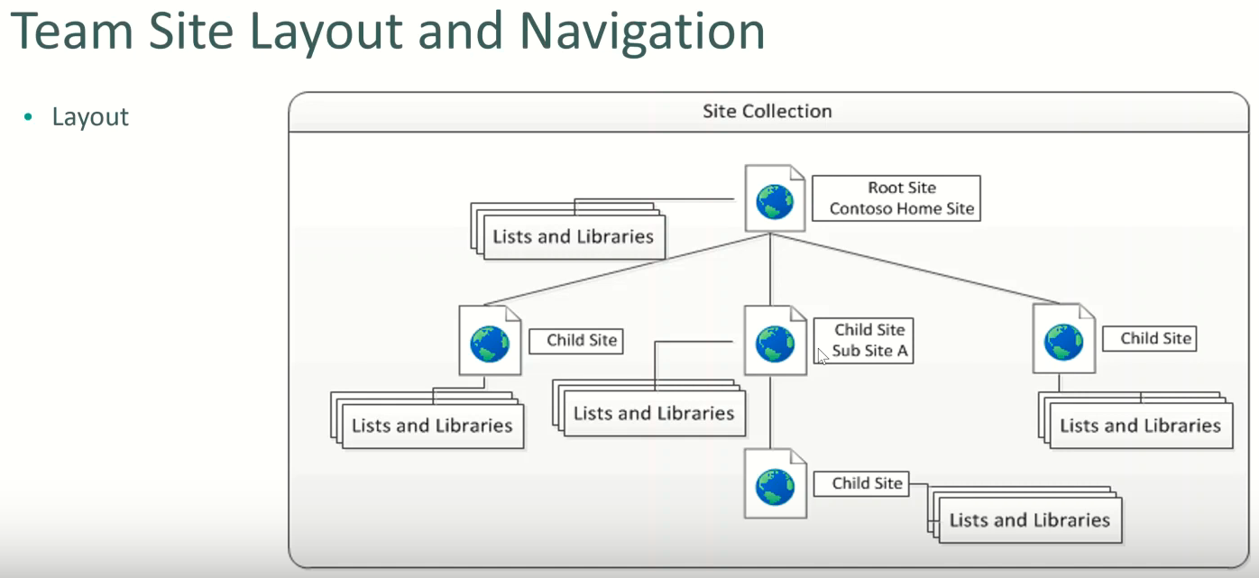

**SharePoint**

**Is used to collaborate/information sharing from the central data**

**1. Sweet page/Global**

**2. Ribbon**

# 2.Edit Page

**Page - Edit->Edit source->down one step the XML note->ok->then write**

**- Checkout->to keep d/t dev. Work when the work at the some time.**

**4. NM**

**5.Notification->to remember site collection**

## a. Editing Top link bar

Add: Bring Facebook URL->Click Edit->Link->Write name->past URL->Save

Delete: Edite->(X) sign next to Facebook

NB: every coloumn has homogenous type of data

## b.Root URL(Universal Resource Locator) and child URL

eg: Go to home at sharepoint page->so the first part upto our site name is the root that is: <https://eyos2011.sharepoint.com/sites/Demo/> but the hole URL is the child:

[https://eyos2011.sharepoint.com/sites/Demo/SitePages/Home.aspx](https://eyos2011.sharepoint.com/sites/Demo/SitePages/Home.aspx    by adding   )

[by adding](https://eyos2011.sharepoint.com/sites/Demo/SitePages/Home.aspx    by adding   )

SitePages/Home.asp

NB: but if you put <https://eyos2011.sharepoint.com/sites/Demo/>

You get

https://eyos2011.sharepoint.com/sites/Demo/SitePages/Home.aspx

b/se it adgusted by dfoalt internally.

## c. promoted links

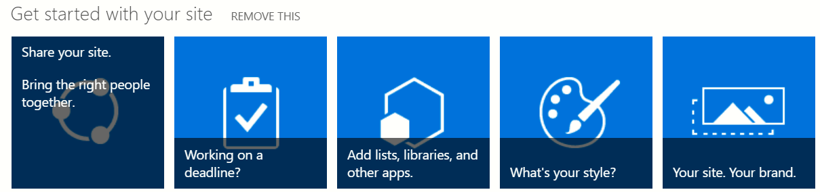

## d.Newsfeed

To Share info. Like Facebook trade

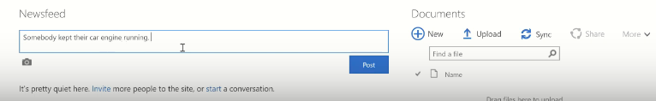

* Upload: To upload the file.

# 3.Setting

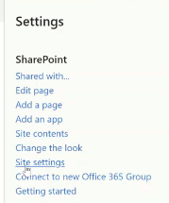

## 3.1. Site Setting

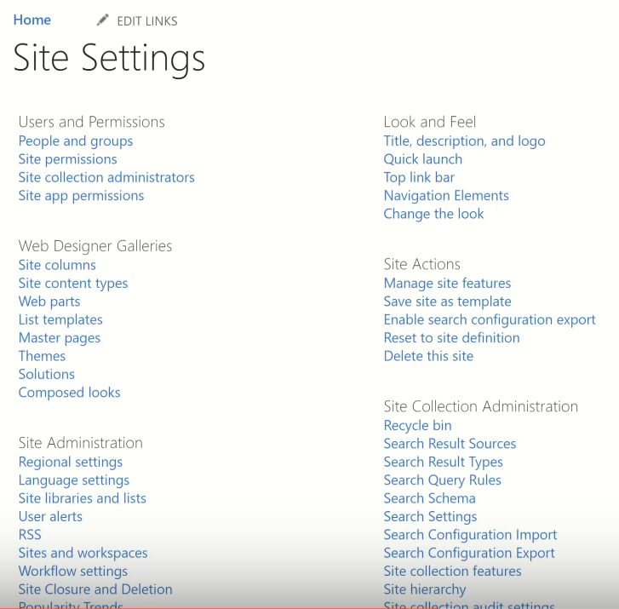

This the num of lists under Site settings are tells full control

## 3.2.Site Logo

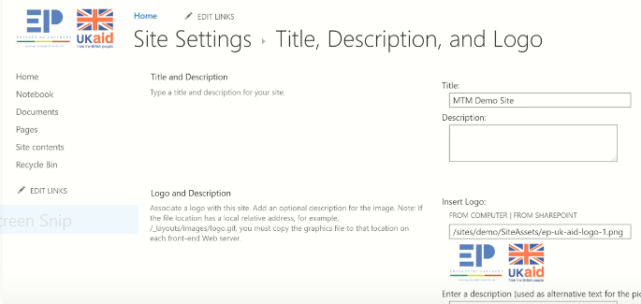

# 4.Lists and Libraries

1. Site collection

* Root Site

=>App(Lists/Libraries)

URL=../A/B/C/D B=>Sub Site

=>App(Lists/Libraries)

C=>Sub Site

=>App(Lists/Libraries)

D =>Sub Site

**Lists and Libraries** are take the most part of the portion

To store data in SharePoint we use Either **Library or List**

## 4.1.Site setting>Quick launch

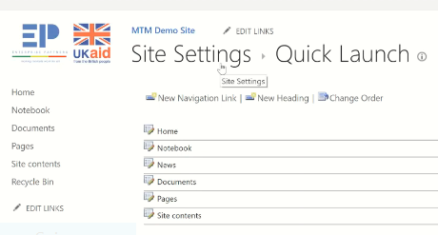

## 4.2.Site setting>Navigation Element

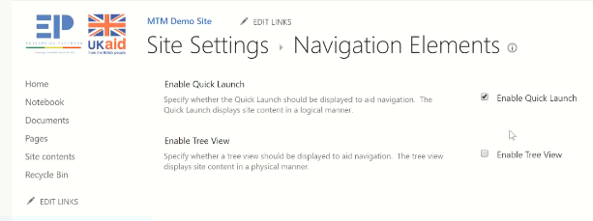

## 4.3.Site setting>Site feacture/Breadcrumb

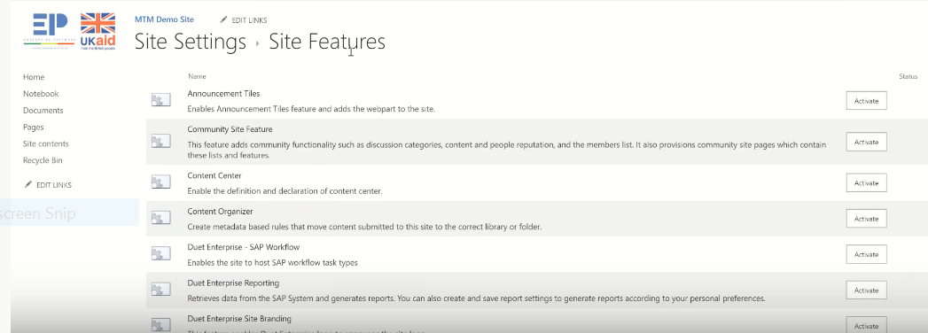

**NB**: **The extreme position of SharePoint Dev. Is Site collection administrator**

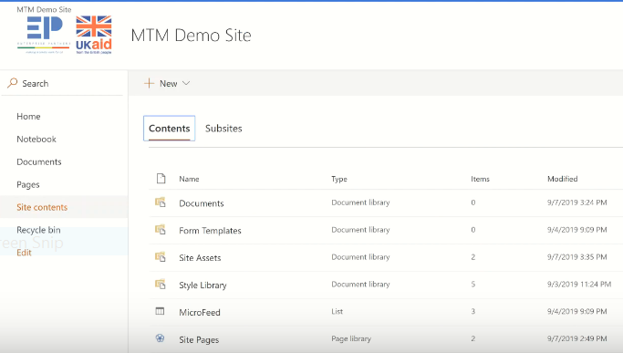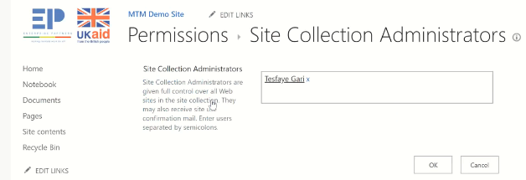

**Only Site collection administrator can see/open site collection button.**

## 4.4.Adding files

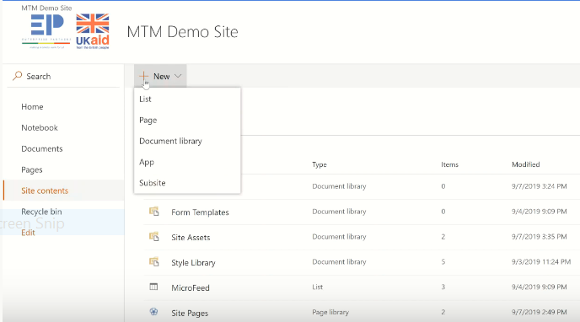

**4.5.To chech how many sub sites are there**

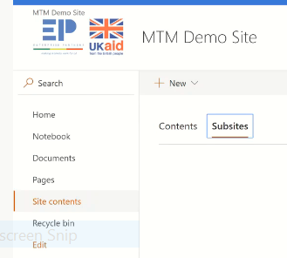

## 4.6.Cotent in classic feacture

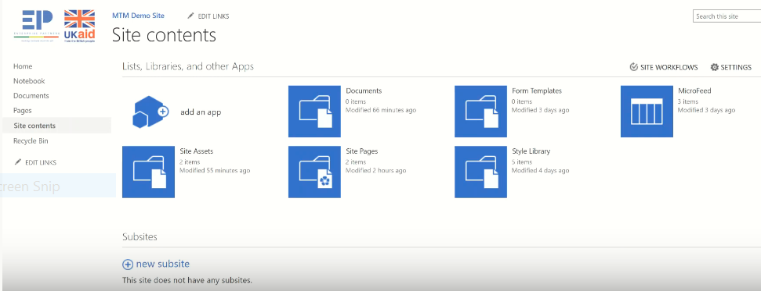

**In this table we have 5 libraries , we differenciated then by looking envelop sign on them.**

## 4.7.Add and App

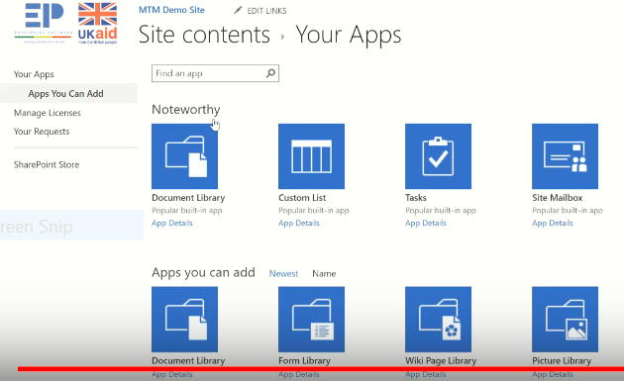

NB:

* From libraries = Docmunt library
* From Lists = Custom list are kind of popular

## 4.8.List and libraries

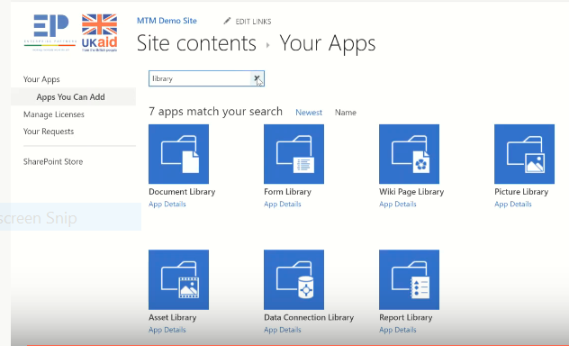

## 4.9.Document

**Record(list of products)**

* Its info need atable.that is the list.
* To start the list from the scratch use custom list

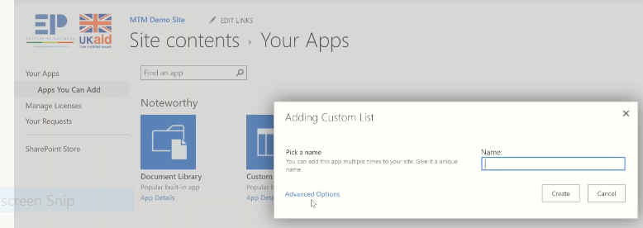

**Description**

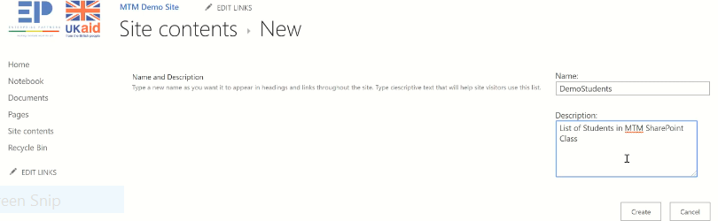

**We get list/table**

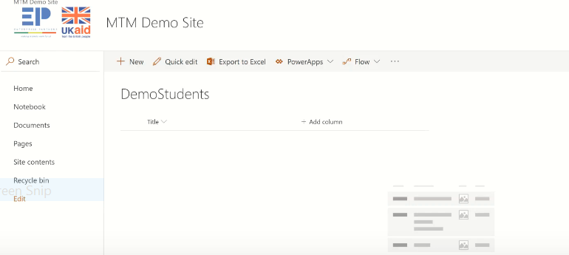

## 4.10. Task and event

1. **Task** = is a kind of command: it has

* Name eg. Clean the house
* Discriotion: eg.1st,2nd floor
* Due date: start 4:00
* Assign to

1. **Event** = has

* Name,Location,start date,end date,description,organizer,participant

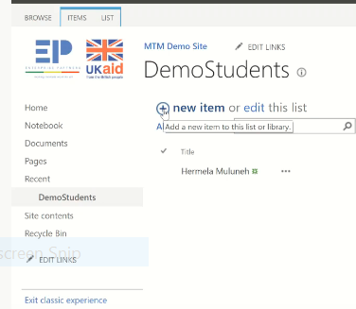

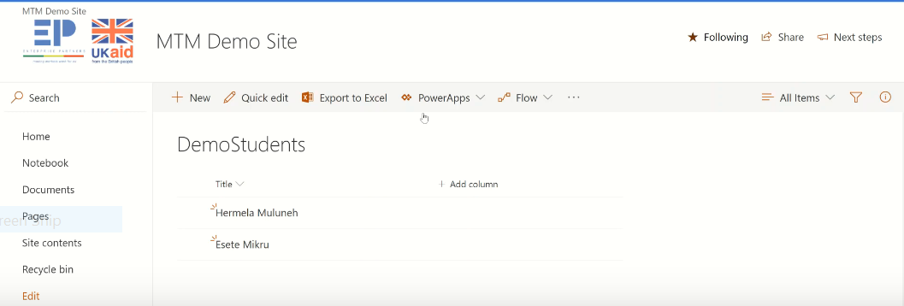

NB: **List** = the hole table

**Item**=each item

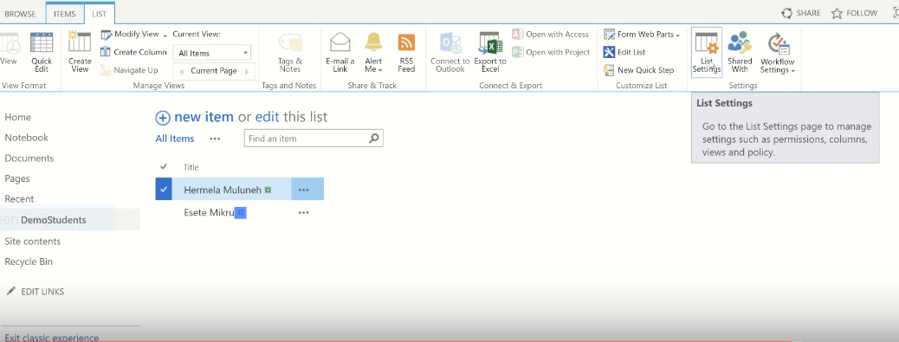

Everything which need to change in the list

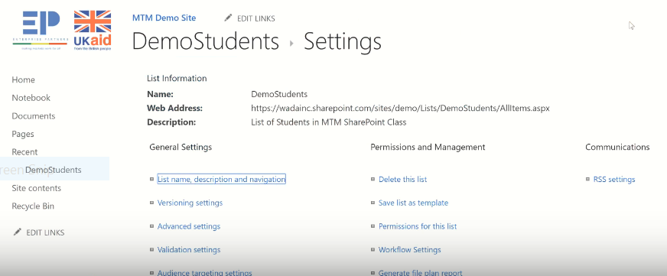

## 4.11.Editing quick launch

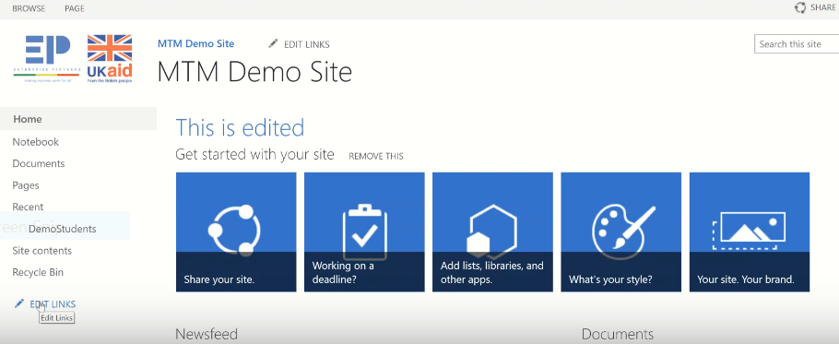

**Then drag it to parallel**

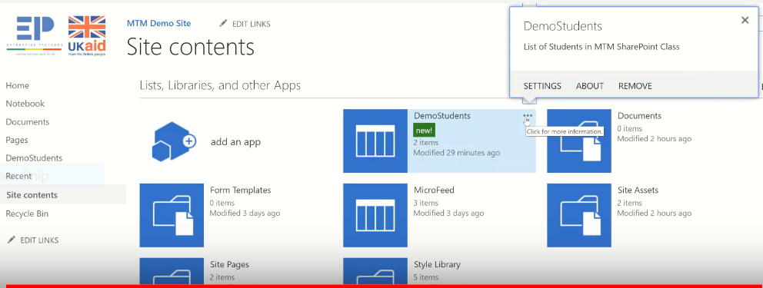

**By clicking the setting**

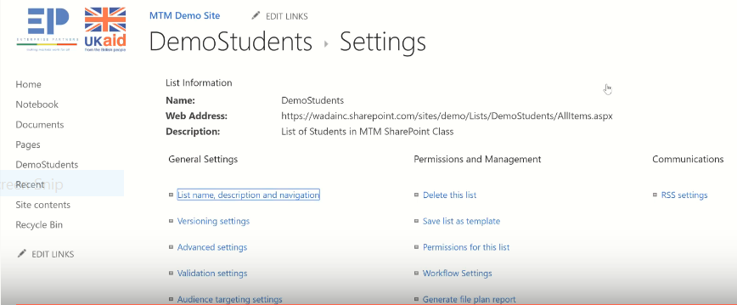

**By clicking list name…**

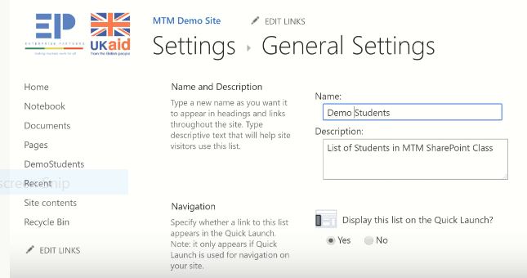

# Summary

1. **Site collection: URL=>URL**
2. **Creating New site collection:New=>Private=>**
3. **SubSite: Site content->SubSite->**
4. **Custom Page: Classic/More feacture=>select**
5. **Page Edit: page->Edit ->Edit source->down one step the XML note->ok->then write**
6. **Page Checkin: page -> Checkin ->to keep d/t dev.comment**
7. **Notification->to remember site collection**
8. **Follows: => to see how many site collections/followers we have**
9. Add Facebook: Facebook URL->Click Edit->Link->Write name->past URL->Save
10. Delete Facebook: Edite->(X) sign next to Facebook

* Root URL: <https://eyos2011.sharepoint.com/sites/Demo/>
* Child URL: [/sites/Demo/](https://eyos2011.sharepoint.com/sites/Demo/)

1. promoted links:
2. Newsfeed. To Share info. Like Facebook trade

Under Setting->(Site Setting)

1. **Site Logo: Setting->Site Setting->**Logo=>Computer

* From libraries = Docmunt library
* From Lists = Custom list are kind of popular

**Document**

**Record(list of products)**

* Its info need atable.that is the list.
* To start the list from the scratch use custom list
* Task and event

1. **Table**: To start the list from the scratch use custom list
2. **Edit the List Name**: Site content->our List(…)->Setting->list,..